ATLANTIC COUNTY DIVISION OF PUBLIC HEALTH
ENVIRONMENTAL HEALTH UNIT
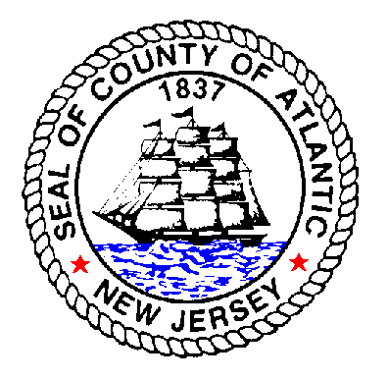
201 SOUTH SHORE ROAD
NORTHFIELD, NJ 08225
(609) 645-5972
www.aclink.org

BODY ART ESTABLISHMENT APPLICATION

Owner’s Name Telephone #

Home Address
Street Address

Municipality State Zip Code

Business Name Telephone #

Address Fax #/e-mail
Street Address

Municipality State Zip Code

Applicant (check one) _____ Individual _____ Partnership _____ Firm or Corporation

List all partners and officers of corporation/firm:

Municipal Approval – for proposed construction or expansion of body art facility

Zoning - Date approved Name of official

Planning- Date approved Name of official

Check all of the following services you will be providing:

- Body Piercing
- Ear Piercing (trailing edge of ear)
- Permanent Cosmetics
- Tattooing
- Other (specify)

Hours of operation

Water supply: city well Sanitary sewer : city on site

Solid waste removal company

Containers Dumpster

Check all of the following services you will be providing:

Body Piercing Ear Piercing (trailing edge of ear)

Permanent Cosmetics Tattooing

Other (specify)

Name of operator

***The following documentation for the operator must be submitted with this application:

    - Verification of 12 months previous experience in operating a body piercing/tattooing facility
    - One or more samples of advertising

Name(s) of practitioner(s)
Check services provided:
- Body piercing (1000 hrs of training)
- Tattooing (2000 hrs. of training)
- Permanent cosmetics (100 hrs. of training)
- Ear piercing

Name(s) of practitioner(s)
Check services provided:
- Body piercing (1000 hrs.of training)
- Tattooing (2000 hrs. of training)
- Permanent cosmetics (100 hrs. of training)
- Ear piercing

Name(s) of practitioner(s)
Check services provided:
- Body piercing (1000 hrs.of training)
- Tattooing (2000 hrs. of training)
- Permanent cosmetics (100 hrs. of training)
- Ear piercing

Name(s) of practitioner(s)
Check services provided:
- Body piercing (1000 hrs.of training)
- Tattooing (2000 hrs. of training)
- Permanent cosmetics (100 hrs. of training)
- Ear piercing
*** The following documentation must be provided for each practitioner with this application:
    - Certification of training for each of the services provided
    - Provide evidence of completion of a blood borne pathogen course
    - A minimum of 10 photographs of original work performed and client applications
(body piercing and tattooing only)
    - Photos of: eyebrow simulation procedures; lip lining or shading procedures; eyeliner and / or eyelash enhancement procedures (permanent cosmetic only)
    - Copy of certification from the American Academy of Micropigmentation and / or Society of Permanent Cosmetic Professionals and / or SofTap (R) Inc., ( permanent cosmetics only) *by February 19, 2004*
    - 16 hours additional training for areola restoration (permanent cosmetics only)
    - 16 hours additional training and 6 months experience for camouflage repairs (permanent cosmetics)
    - Documentation of completion of training program (ear piercing only)
    - Proof of professional malpractice liability insurance for each practitioner

CERTIFICATION BY APPLICANT
I have received and read Chapter 27 of the New Jersey Administrative Code, and I certify that this Body Art
Establishment meets these standards. I understand that obtaining a license by means of fraud, misrepresentation or concealment shall result in closure of the Body Art Establishment. I certify the statements made in this application are true, complete and correct to the best of my knowledge and belief.
Name of Applicant (Print) Title of Applicant

Signature of Applicant Date

The following paperwork must be submitted with this application:

- A diagram of the floor plan showing the reception, procedure, cleaning and sterilization, storage areas and toilet facilities (include area measurements)
- Names and addresses of all manufacturers of processing equipment, instruments, jewelry and inks used in all procedures
- Photograph of autoclave
- Negative biological of autoclave
- Manufacturer’s instructions for autoclave
- Copy of malpractice insurance for each practitioner
- Copy of informed consent for each procedure
- Copy of after care instructions for each procedure
- Copy of client application
- Policies for HBV vaccine series
- Policies for latex allergies
- Written agreement with physician ( body piercing and permanent cosmetics only)
- Documentation of qualifications for all personnel

FOR HEALTH DEPARTMENT USE ONLY

Application Submitted Est # Program Code 404

Date Approved Signed By

Autoclave: Submit for review - a photograph of steam autoclave with make, model # and serial # printed on the back
- a copy of the manufacturer’s instructions for operation of the autoclave

Name of biological monitoring laboratory Tele #

Will you be reprocessing reusable equipment? Yes/No

Will you be needle building? Yes/No

Medical waste generators permit #
***Submit a copy of the Medical Waste Permit

List any employees who have received the Hepatitis B vaccination series

